

**19 JUNE, 2017**

**Arrival**

**20 JUNE, 2017**

**Registration:** 9.00-15.00

**Location:** Council Room, Faculty of Agricultural and Food Sciences and Environmental Management, Debrecen, Böszörményi str. 138. Hungary

**Opening ceremony:** 10.00-10.30

**Location:** Council Room, **Chairman:**Prof. Dr. András Nábrádi

10. 00- 10: 15. Dr. László Papp, Major of Debrecen

10.15- 10.20: Prof. Dr. Károly Pető, Dean of the Faculty of Economics and Business

10.20-10.30: Signing the Double Degree Agreement: Prof. Dr. Mashir Erdenebayar, Program Director (Mongolian State University of Life Sciences) and Prof. Dr. Elek Bartha, Vice Rector (University of Debrecen)

**Plenary session I:**

10.30-10:50. Prof. Dr. Bruce Ahrendsen, Arkansas, USA

***“Agricultural Policy Changes with a New US Government: ’America First’?”***

10.50-11:10. Prof. Dr. Wim Heijman, Wageningen, the Netherlands

***“Will Brexit Influence the CAP after 2020?”***

11.10- 11.30. Prof. Dr. Zoltán Szakály, Debrecen, Hungary

***“Sustainability Marketing and Locality: What do Consumers Think about It?”***

11.30-12.00. **Questions, discussion**

**12.00-13.30 Lunch, Location: VIP Restaurant**

**Plenary session II.**

13:30-13.50. Prof. Dr. András Nábrádi & Dr. Krisztián Kovács, Debrecen, Hungary

***“10 Years Anniversary of APSTRACT”***

13.50-14.10. Dr.Tatiana Litvinenko & Prof. Dr. András Nábrádi

***“How the AGRI-MBA Network will be Sustainable in the Changing World?”***

14.10-14.30. Assoc. Prof. Dr. Zsolt Csapó, Debrecen, Hungary

***“MBA Education at the University of Debrecen and Its Further Development towards Double Degree Programmes Incorporating New, Innovative “Learning by Doing” Educational Method, Called “Team Academy Method””***

14.30-15.00.

**Questions, discussion**

**18.00-19.00: Sightseeing walking tour in the city centre. Meeting point:** [**Great Calvinist Church**](https://www.google.hu/maps/place/Debrecen-Nagytemplomi+Reform%C3%A1tus+Egyh%C3%A1zk%C3%B6zs%C3%A9g/@47.5322646,21.6221089,17z/data=!3m1!4b1!4m5!3m4!1s0x47470e0b16624e85:0x86950f7a0a6bcbfb!8m2!3d47.5322646!4d21.6242976)**, at 17.45. End of the tour: Csokonai Restaurant, 19.00**

**19.00- 23.00 Gala dinner at** [**Csokonai Restaurant**](http://csokonaisorozo.hu/en/) **Deluxe Event Hall, 21 Kossuth str.**

Dresscode: smart casual

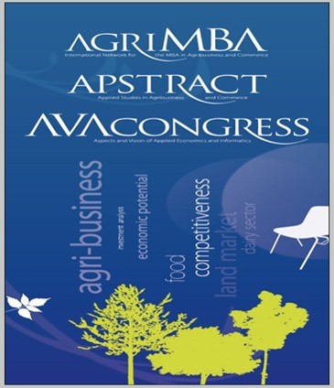

**21 JUNE, 2017**

**Registration:** 9.00-16.00.

Parallel sessions: **Location 1**: Council Room, Faculty of Agricultural and Food Sciences and Environmental Management

AND

**Location 2**: Lecture Hall 6, Faculty of Agricultural and Food Sciences and Environmental Management

**Location 1:** Council Room, Faculty of Agricultural and Food Sciences and Environmental Management, Debrecen, Böszörményi str. 138. Hungary

**Session: Applied Agricultural Economics, *Chairman: Zsolt Csapó, Hungary. Secretary: Szilvia Molnár***

9.00-9.20: Andrey Babenko - Leonid Mukhin: Recruiting Recent Graduates to Work at Agricultural Enterprises: Siberian Region Case Study

9.20-9.40: Imre Milán Harcsa: Increasing Palinka Reputation with Tourism and Gastronomy

9.40-10.00: Viktória Vida – István Szűcs: Pork Meat at a Glance - Production, Trade and Consumption in Comparison with China and Hungary

10.00-10.20: Beáta Bittner: Tobacco Growers’ Possibilities for Maintain their Activity in Hungary

**10.20-10.40: Coffee break**

10.40-11.00: Szilvia Molnár - László Szőllősi: Economic Issues of Duck Production: A Case Study from Hungary

11.00-11.20: Krisztián Kovács - Ratnesh Pandey: Hungarian Dairy and Beef Production Sector Technical Efficiency Comparing using DEA

11.20-11.40: Zoltán Gabnai - Attila Bai: Opportunities of Energy Production and -Usage in Large-Scale Wastewater Treatment

11.40-12.00: Mario Njavro - Josip Juračak: Risk Management in Croatian Agriculture

12.00-12.20: Laura Karnai – Krisztina Ladányi – Szilvia Molnár: Analysis of costs and income in pig slaughtering (case study)

**12.30-14.00. Lunch, Location: VIP Restaurant, Böszörményi str. 138.**

**Session: Management and Information Technologies, *Chairman: Andrey Babenko, Russia. Secretary: Krisztina Ladányi***

14.00-14.20: Tünde Csapóné Riskó – Troy Wiwczaroski: Globalisation – Power and Responsibility of Companies

14.20-14.40: Syed Zaheer Abbas Kazmi - András Nábrádi: Assessment of the Business Students’ Entrepreneurial Intentions

14.40-15.00: László Várallyai - Szilvia Botos - Ádám Péntek: Usage of Innovative ICT Tools in Hungarian SMEs on the Northern Great Plain Region

15.00-15.20: Julia Tobak: The Main Factors of the Effective Operation in Case of Hungarian Family - Owned Businesses

15.20-15.40: Péter Popovics - Tímea Gál - Georgina Árváné Ványi - Judit Katonáné Kovács: Learning Plans and Expectations of Students after Bachelor Studies – a Survey at the University of Debrecen

15.40-16.00: László Kozár - György Iván Neszmélyi: Hungarian Endeavours for the Enhancement of Economic Relations in Southeast Asia, Focusing on a New Partnership with Vietnam

**16.00-16.20: Evaluation of the Sessions by the Chairmen, closing**

**Location 2: Lecture Hall 6*,*** Faculty of Agricultural and Food Sciences and Environmental Management, Debrecen, Böszörményi str. 138. Hungary

**Session: Financial Management and Accounting, *Chairman: Harry Bremmers, the Netherlands. Secretary: Julia Tobak***

9.00-9.20: Péter Gál: Factors Influencing Grape Prices in Hungary and the EU

9.20-9.40: Ferenc Buzás – László Posta – S. Kiss: Determining Fair Rental Value of Land – a Methodological Approach

9.40-10.00: Miklós Vásáry - Zsolt Baranyai - Árpád Papp-Váry: Brexit Analysis from the Agriculture’s Aspect

10.00-10.20:Zsuzsanna Tóth-Naár - Pál Ádám Sőreg - Tamás Antal Naár - Sergey A. Vinogradov: The Investigation of Factors Influencing the Market Prices of Agricultural Land in Hungary

**10.20-10.40: Coffee break**

**Session: Regional and Rural Development, *Chairman: Erdenechuluun Tumur, Mongolia. Secretary: Julia Tobak***

10.40-11.00: Anastasia Chaplitskaya - Wim Heijman - Johan van Ophem: Analysis of Sustainable Development of Regional Agriculture using Composite Indicators (adapted from Stavropol Territory, Russia)

11.00-11.20: Robert Magda: The Role of Sustainable Natural Resource Utilisation in our Future in Middle Europe

11.20-11.40: Mehmet Sercan Önalan - Miklós Vásáry: Rural Entrepreneurship in Turkey

11.40-12.00: Ilona Liliána Birtalan - György Bárdos: The Phenomena of Community Supported Agriculture: Membership Mechanisms

**12.30-14.00. Lunch, Location: VIP Restaurant, Böszörményi str. 138.**

**Session: Tourism and Sport Management, *Chairman: Johan van Ophen, the Netherlands. Secretary: Zoltán Gabnai***

14.00-14.20: Piroska Béki: Climate Change Effects on Ski Tourism

14.20-14.40: Nikolett Kosztin - Ildikó Balatoni: Bike Path Developments in the North Plain Region

14.40-15.00: Éva Görgényi Hegyes - Balázs Máté - Seyyed Amir Vafaei - Mária Fekete Farkas: The Role of Social Media in Gastronomy Industry

15.00-15.20: Undrakh Zagarkhorloo - Wim Heijman - Liesbeth Dries - Agipar Bakey: Community Based Tourism Management: Core Relationships in Collective Action

15.20-15.40: Henrietta Szépné Varga - Ildikó Balatoni: Infrastructural Background of the Every-Day Physical Education in Hungarian High Schools

**Session: Commerce and Marketing, *Chairman: Mario Njavro, Croatia. Secretary: Krisztina Ladányi***

15.40-16.00: Ágnes Papp-Bata - András Jávor - Anikó Nagy - István Monori - József Prokisch - Zoltán Csiki - Zoltán Szakály: Effects of Mg and Se Intake for Lambs on Meat Quality, Consumers’ Dietary Attitudes and Health

16.00-16.20: Bálint Horváth - Ákos Bartha - Izabella Mária Bakos: The Tendencies and Determining Factors of Food Waste in Hungary

16.20-16.40: Zsolt Polereczki - Fédra Barna - Lilla Prokisch - Sándor Kovács - Zoltán Szakály: Consumption of Herbs in Hungary

16.40-17.00: Tünde Csapóné Riskó - Ádám Péntek – Troy Wiwczaroski: Bread Consumption Habits in the Gluten Free Diet

**17.00-17.30: Evaluation of the Sessions by the Chairmen, closing**

**19.30- 22.00. Dinner, Location:** [**Nagyerdei Water Tower**](http://hirek.unideb.hu/en/news/20170206_double-recognition-nagyerdei-water-tower) **(Debrecen, Pallagi út 7, 4032)**

**22 JUNE, 2017**

**Whole Day Field Visit**

Pick up time:

8.00 Hotel Lycium,

8.30 Hotel Aquaticum,

9.00 Campus (Böszörményi str. 138)

**Programme:**

10.00: [Eco touristic centre of Lake Tisza](http://www.tiszataviokocentrum.hu/en/) (Poroszló)

13.30: Lunch at [Fehér Amur Restaurant](http://www.feheramur.hu/)

18.00: Wine dinner in Eger at [Gál Tibor Winery](http://www.galtibor.hu/en/)

**Arrival to Debrecen: approx. 22.00**

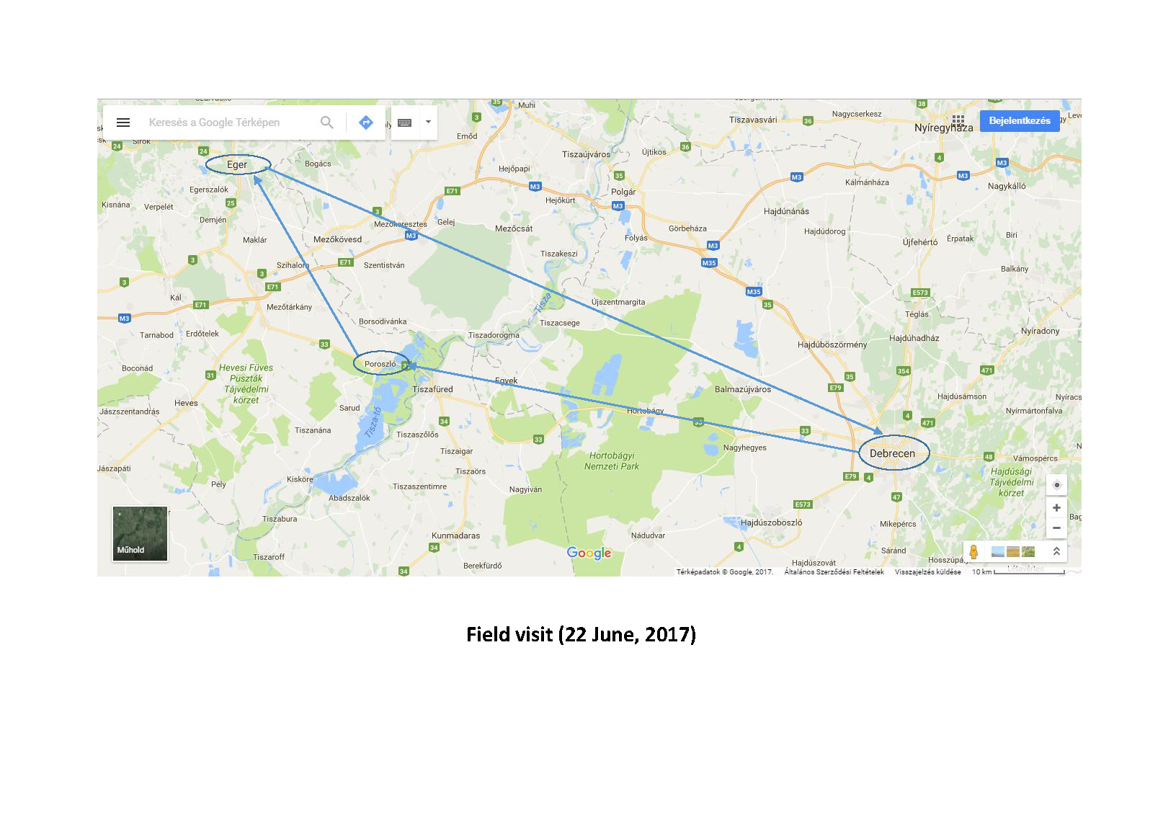

**23 JUNE, 2017**

9.00-16.00 **AGRIMBA Executive and General Board Meeting**

**Location: Council Room of the Faculty of Economics and Business, „TVK Building”**

**13.00- Lunch, Location: VIP Restaurant, Böszörményi str. 138.**

**24 JUNE, 2017**

**Departure, Farewell**